Generate keys

ssh-keygen -t rsa -b 4096

Press enter **Don’t change the file path, leave it blank**



Leave the passphrase blank and press enter



cat /root/.ssh/id_rsa.pub

#copy the value, just select don’t put any extra space

[](https://usercontent.one/wp/www.openwriteup.com/wp-content/uploads/2023/08/git5.jpg?media=1728024675)

o to: Settings -> SSH & GPG keys -> SSH Keys  
Click ‘New SSH key’  
Title “Public repo-key”

[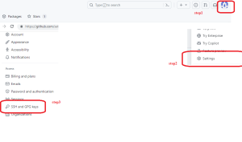](https://usercontent.one/wp/www.openwriteup.com/wp-content/uploads/2023/08/git6.png?media=1728024675)

Add keys

[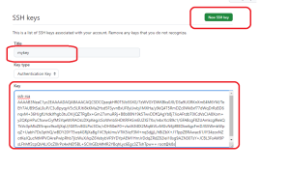](https://usercontent.one/wp/www.openwriteup.com/wp-content/uploads/2023/08/git7.png?media=1728024675)

**Configuring SSH for Git and push**

**Youtube link**: [Navigation to pefrom lab](https://www.youtube.com/watch?v=nLnokLBJ-C4&list=PLwO9EbabNLzsaHgP1dUCkdLg2CxZoPXGR&index=4)

This lab has three parts:

**Part1: Create a github account**

1. Go to github.com
2. Incase you have existing github account please use or sign up for a new account
3. If you choose to sign up for a new account, click ‘Sign up’ at the top right
   1. Create a username. You might need to use a personal email address
   2. You will need to check your email and verify that your email address is real

**Part2: creating repo on github**

Create a private repository in your GitHub account called “gittraining”  
a. Name: repo-lab  
b. Choose ‘Public’  
c. Do not initialize with a README  
d. Click the green ‘Create Repository’ button

[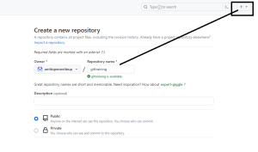](https://usercontent.one/wp/www.openwriteup.com/wp-content/uploads/2023/08/git.png?media=1728024675)

Copy the SSH URL under ‘Quick Setup’

[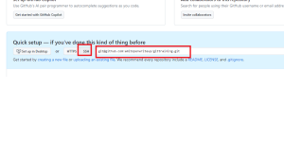](https://usercontent.one/wp/www.openwriteup.com/wp-content/uploads/2023/08/git2-1.png?media=1728024675)

On your remote putty: in the my-repo directory:

# Below are the example, please change the command as per your git repo

git branch -M main

git remote add origin git@github.com:amitopenwriteup/gittraining.git

git push -u origin main